Wi-Fi Repeater

📡 What is a Wi-Fi Repeater?
# Source: AI Source: Provided by: [Data Path: Persons Table -> ID Column: 1, Name_En Column: Motasem Essam] -> From: [ChatGPT] on [12/18/2025]
A Wi-Fi Repeater (also called a Wi-Fi Range Extender) is a network device that receives an existing Wi-Fi signal, amplifies it, and rebroadcasts it to areas where the original signal is weak or doesn't reach.
✅ Its purpose is to extend Wi-Fi coverage — especially in large homes, offices, or areas with walls and obstacles.

🔧 How a Wi-Fi Repeater Works
# Source: AI Source: Provided by: [Data Path: Persons Table -> ID Column: 1, Name_En Column: Motasem Essam] -> From: [ChatGPT] on [12/18/2025]
- Connects wirelessly to your main Wi-Fi router.
- Receives the signal from the router.
- Repeats or rebroadcasts the signal to nearby devices.
- Devices connect to the repeater instead of the main router.

🏠 Example Use Case
# Source: AI Source: Provided by: [Data Path: Persons Table -> ID Column: 1, Name_En Column: Motasem Essam] -> From: [ChatGPT] on [12/18/2025]
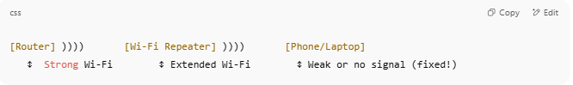

[Router] )))) [Wi-Fi Repeater] )))) [Phone/Laptop]
↕ Strong Wi-Fi ↕ Extended Wi-Fi ↕ Weak or no signal (fixed!)

- Use it in hallways, basements, or rooms far from the router.

🧱 Placement Tip
# Source: AI Source: Provided by: [Data Path: Persons Table -> ID Column: 1, Name_En Column: Motasem Essam] -> From: [ChatGPT] on [12/18/2025]
Place the repeater:
- Halfway between the router and the weak area
- Where it still gets a good signal from the router

🧠 Key Features
# Source: AI Source: Provided by: [Data Path: Persons Table -> ID Column: 1, Name_En Column: Motasem Essam] -> From: [ChatGPT] on [12/18/2025]
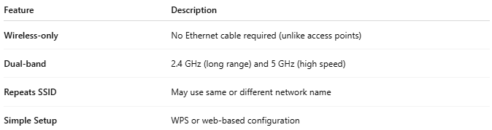

Feature | Description
Wireless-only | No Ethernet cable required (unlike access points)
Dual-band | 2.4 GHz (long range) and 5 GHz (high speed)
Repeats SSID | May use same or different network name
Simple Setup | WPS or web-based configuration

🆚 Repeater vs Extender vs Mesh
# Source: AI Source: Provided by: [Data Path: Persons Table -> ID Column: 1, Name_En Column: Motasem Essam] -> From: [ChatGPT] on [12/18/2025]
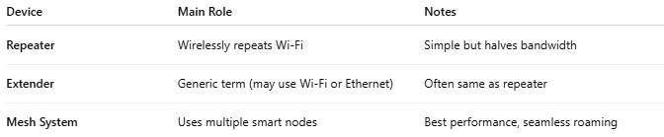

Device | Main Role | Notes
Repeater | Wirelessly repeats Wi-Fi | Simple but halves bandwidth
Extender | Generic term (may use Wi-Fi or Ethernet) | Often same as repeater
Mesh System | Uses multiple smart nodes | Best performance, seamless roaming

✅ Pros
# Source: AI Source: Provided by: [Data Path: Persons Table -> ID Column: 1, Name_En Column: Motasem Essam] -> From: [ChatGPT] on [12/18/2025]
- ✅ Increases Wi-Fi range
- ✅ Easy to set up
- ✅ No cabling needed
- ✅ Cheap compared to mesh systems

❌ Cons
# Source: AI Source: Provided by: [Data Path: Persons Table -> ID Column: 1, Name_En Column: Motasem Essam] -> From: [ChatGPT] on [12/18/2025]
- ❌ Halves bandwidth (repeats signal on same radio band)
- ❌ More latency than wired access points
- ❌ May cause roaming issues (devices may cling to weaker router signal)
- ❌ Less effective in very large or complex buildings

📌 Summary
# Source: AI Source: Provided by: [Data Path: Persons Table -> ID Column: 1, Name_En Column: Motasem Essam] -> From: [ChatGPT] on [12/18/2025]
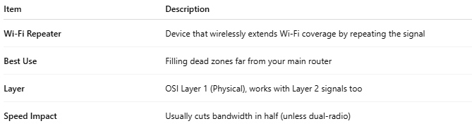

Item | Description
Wi-Fi Repeater | Device that wirelessly extends Wi-Fi coverage by repeating the signal
Best Use | Filling dead zones far from your main router
Layer | OSI Layer 1 (Physical), works with Layer 2 signals too
Speed Impact | Usually cuts bandwidth in half (unless dual-radio)

